Assignment 1 of 3.

Goals of the project.
The goal of the project was to write a web system that asks the user for input values, and then the systems goal was to change the value that is equal to the first input value the user inserted to the second value they inserted, as well as allowing multiple users to change values at the same time.

Issues of the project
The main problem was to get the system to allow multiple users to edit the file at the same time without causing any inconsistencies in the data. For example, if two users simultaneously open the web system and both changes the same word within the text file, then only the persons’ data who was a few split seconds later in the process’ data will be changed and the first persons’ data will be lost. The problem here was to find a method that would allow multiple users to edit the file at the same time, without wasting the users time by having them wait until the other person has completed, by only locking the file once the user has submitted the update and the system then writes the data to the file.
Issues with locking: If a file is accessed from several different machines on the same time, then a lock that was obtained on one machine cannot be detected by another machine. If this happens, two or more users on different machines can lock the same file for their own use, and all the users think that their read/write processes are being done by only their machines, and then a race condition will occur.

Possible Solutions that might be used.
There are a few possible solutions that might be used to regulate the problem of data loss or data inconsistencies.
One way is to have a single writer, and many readers. Multiple users can access the same file, but everyone except the first person on the server has to be in read only. So only the unique process that can read, write and update, will serve as a parent process, and all other processes that wants to update or write to a file can only do so through interprocess communication with that one process.
Another option is to let all the users access the same file, and all the people will see the updates in near real time.
Another possible solution is to assign permissions or access rights to specific users and groups of users. This controls the user’s ability to access, view, change, and execute the contents of a file. You can implement this with an access-control list (ACL). The ACL is just a list of permissions attached to an object. The ACL specifies which users or system processes are granted access to objects, and what operations are allowed to be executed.
File locking is another mechanism to prevent data inconsistencies. File locking restricts the access to a file by allowing only one process or user to access a specific file at a specific time. By implementing file locking you can prevent the classic intercepting update scenario by enforcing serialization of update processes to any given file. The locks only works on a single machine, therefore the only way to deal with multiple users sharing a file system, is to have all users login to the same machine

Development on the system.
I first started with the HTML form of the system.
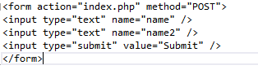
There is nothing special about this form. It’s a straight HTML form with no tags of any kind. The user fills in the two text boxes, and when they hit the submit button, the index.php page is called. The method attribute specifies how to send form-data. The form-data can be sent as HTTP post transaction with the method=’POST’ and the form-data can be sent as URL variables, with the method=’get’.
I then started my php.
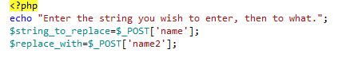
I used the echo() function to output a string value. Then I placed the two values from the text boxes into two variables with the POST method.
I then added a text file with the name Contents1 to my system.
After I added a text file and inserted a few values, I created a variable to contain the filename. Then you open the file with an fopen method, while also giving permission to write to the text file. $str variable saves the contents of the file into it with the implode method, and then the str_replace method contains the data about which set of strings to replace with another string value. Fwrite() then writes the data into the text field and the file is closed.
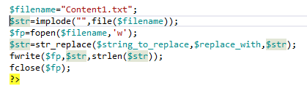
Then I started with the locks so that multiple users can’t edit the file at the same time. 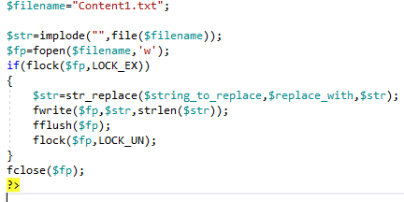
I inserted an if statement to check if the file is locked or not, and if the file is not locked it will lock the file with flock($fp,LOCK_EX). The LOCK_EX is used to acquire an exclusve lock(writer)
The lock jumps in place after the file is opened, and then unlucked with LOCK_UN after the file was written or updated, and before the file is closed.

Conclusion.

With the use of locking, multiple users can access and write/update/change the information in the text file almost simultaneously, without causing any race problems.

